**67. Spring REST - CRUD Database Project - Update Customer**

**Update Customer**:

Here we will update a customer in our "Spring-crm-rest" application. We will use the PUT HTTP method for update customer. We will pass over the new update information for the customer and we'll also specify the user Id.

System perform the operation in the backend and send us the response.

**Application Interaction (Update Customer)**:

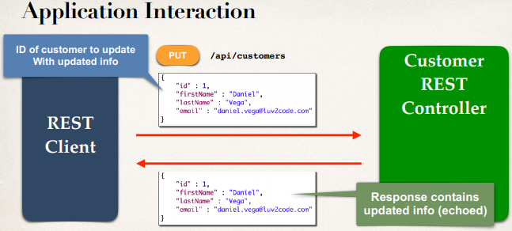

**Update Customer**:

@RestController

@RequestMapping("/api")

**public** **class** CustomerRestController {

...

// add mapping for PUT /customers - Updating existing customer

@PutMapping("/customers")

**public** Customer updateCustomer(@RequestBody Customer theCustomer) {

customerService.saveCustomer(theCustomer);

**return** theCustomer;

}

}

**Postman - Sending JSON in Request Body**:

* Select PUT in postman
* Select raw under body
* Select "JSON(application/json"

67. Spring REST - CRUD Database Project - Update Customer